Assignment-1
BJT and FET Amplifier
Deadline for submission- 29/4/22
Problem-1
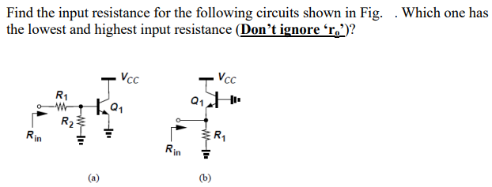
Problem-2
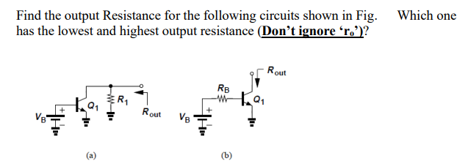
Problem-3
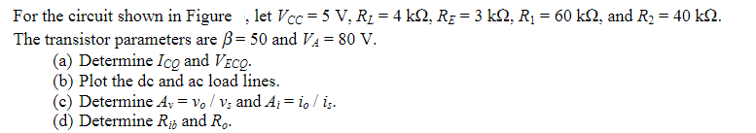
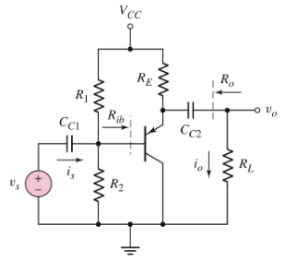
Problem-4
Determine the following. (a) V_{GSQ} and I_{DQ} (b) Draw the D.C load line and determine Q-point.
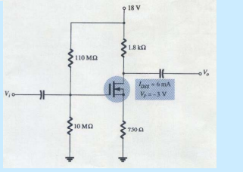
Problem-5
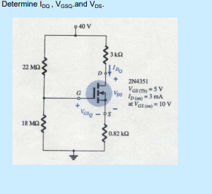
Problem-6
Draw the circuit diagram for the multistage amplifier shown in figure below. Also determine the D.C voltage and current.
